A. Foodservice Concept
- Restaurant name: Abood’s kitchen
- Probably in Anaheim
- Casual/ Family Style.
- Halal/ Arabic food.
- Breakfast and Dinner. From 9 a.m to 1 p.m then from 5 p.m to 12 a.m
- Anaheim’s location is central in Orange County. The proximity to Disneyland makes it a touristy area, as well there are middle eastern people who live in the area.
- The exterior would be contemporary with gray and white bricks. There would be proper landscaping in the entrance. The signage would be lit with a red light by the entrance. And the parking would be behind the building.
- The interior appearance will have a garden feel. Wooden floors and walls in different textures and shades. The seating arrangement will be like the Arabic traditional way, which is low, and all the food is served family style in big plates. The menu will be in a booklet form. Servers would be wearing Arabic traditional cloth to match the theme. The atmosphere would be loud and Arabic music will be playing in the background. Highly focused on delivering the best customer service.
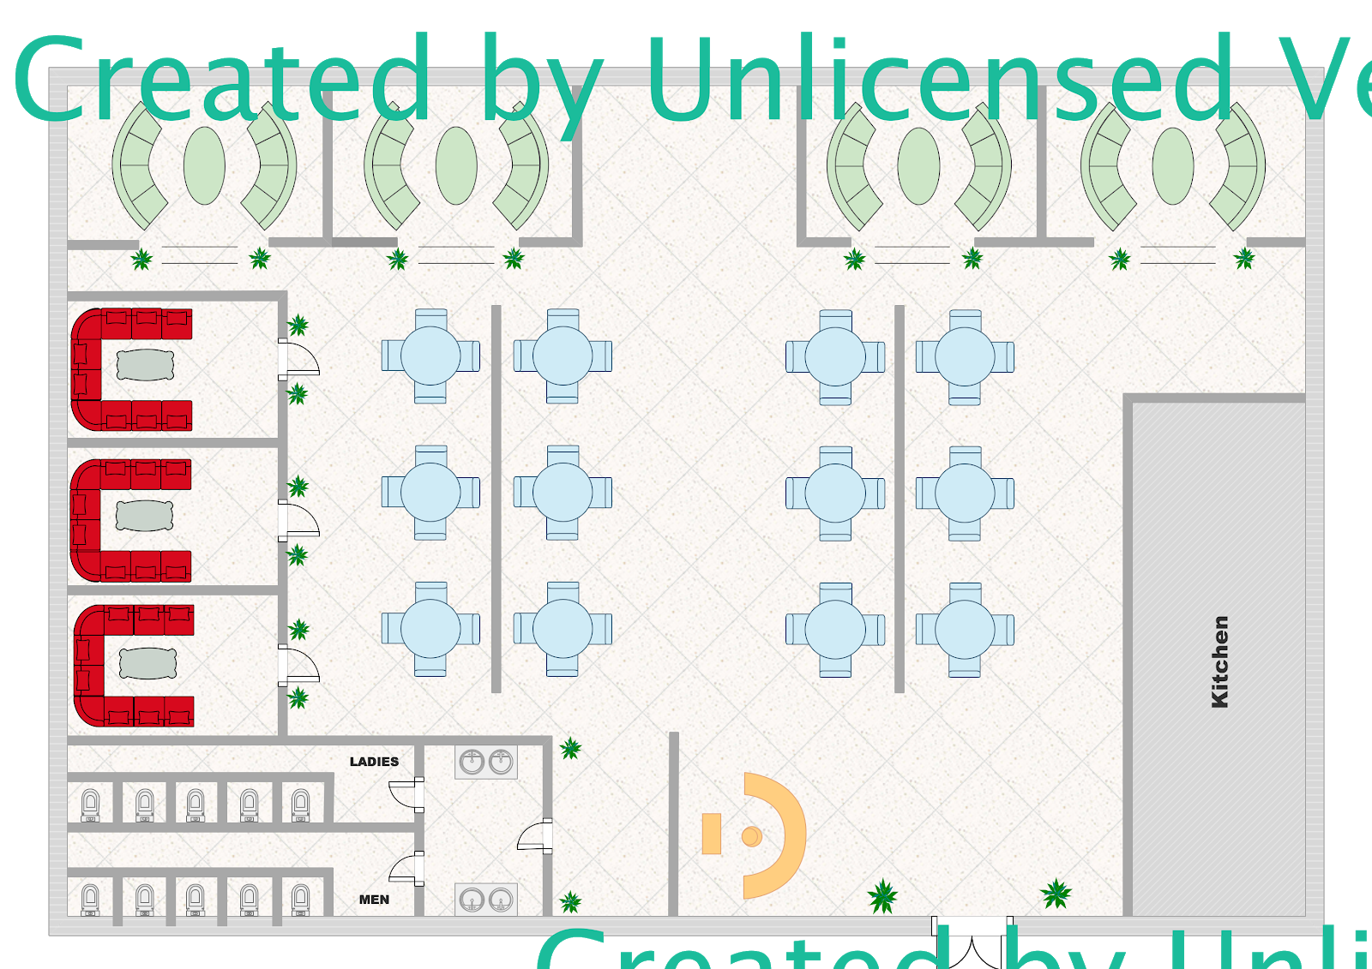

B. Demographic Report
Population Estimates | $ 352,497
Males | $ 166,967 | 47.6%
Females | $ 184,099 | 52.4%
Age:
18 years and over | $ 244,348 | 72.7%
21 years and over | $ 228,674 | 68.0%
62 years and over | $ 39,020 | 11.6%
Marital status & children
Husnad-wife Family | $ 52,518 | 53.4%
Family households | $ 74,294 | 75.6%
with own children under 18 | $ 38,266 | 38.9%
nonfamily households | $ 24,000 | 24.4%
Income
householder living alone | $ 17,448 | 17.8%
Median Household income | $ 64,464
Population density | $ 7,024 | per square mile
Attractions
Disney Land
Downtown Disney
Knot’s Berry Farms
Sleeping beauty Castle
Cars Land
Angel Stadium of Anaheim
Star tours
Adventure City
Space mountain
Occupation types
administrative | $ 22,259 | 13.0%
Sales | $ 16,962 | 10.0%
Management | $ 15,098 | 8.9%
Production | $ 14,233 | 8.4%
Food | $ 13,277 | 7.9%
Personal Care | $ 9,426 | 5.6%
six major employers
1. Disneyland Resort
2. Kaiser Foundation Hospitals
3. AirportBus
4. Northgate González Markets
5. Anaheim Memorial Medical Center
6. AT&T
Education, HS, College, University, etc.
High school graduate or higher |  | 76.6%
Bachelor's degree or higher |  | 25.3%
Race hertage
White alone |  | 68.7%
Black or African American |  | 2.4%
American Indian and Alaska Native |  | 0.4%
Asian |  | 16.5%
Native Hawaiian |  | 0.4%
Two or more Races |  | 3.3%
Hispanic or Latino |  | 53.8%
White alone |  | 25.2%

Target Market:
21 years and over
Family households
Middle Easterns
others races who are interested in different cultures
Students

C.Competitors
Olive Tree Resturant | Brookhurst St | Middle Eastern | Casual | 12 PM-12AM
El Mahroosa Resturant & Café | Brookhurst St | Egyptian, Lebanese | Casual | 9 AM- 1 AM
Zait and Zaatar | brookhurst St | Lebanese | Fast Casual | 8AM-10PM
Aleppo's Kitchen | Anaheim | Mediterranean Syria & Turkish | Fine dining | 12PM-10PM

